Educational Beginner’s Language Game

User Guide

Contents

1. Installation
2. Navigating the menus
3. Choosing your settings
4. Playing the game
5. The score screen
6. Troubleshooting

**1** Installing and running the game

If you have not already installed the game onto your computer, all you need to do is copy the file from the CD, and onto a folder or area of your choice on your computer. This has been shown for you below in three easy steps.

**1.**

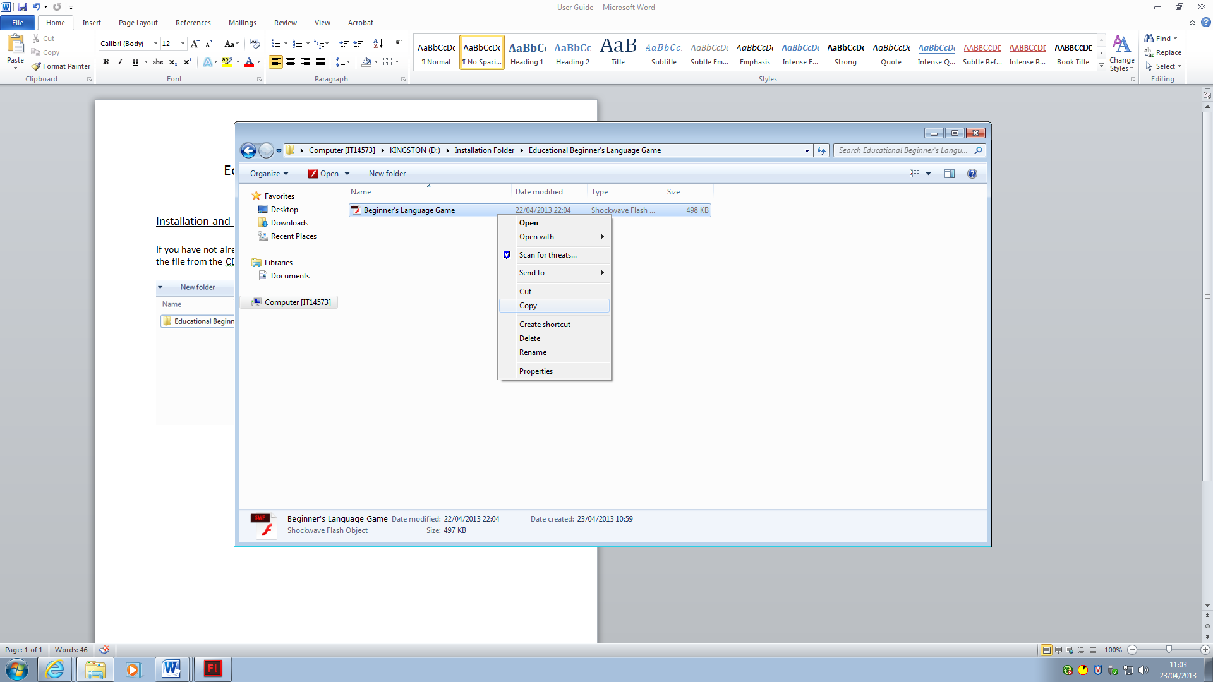

Right-click and select **Copy** from the drop-down menu

**2.**

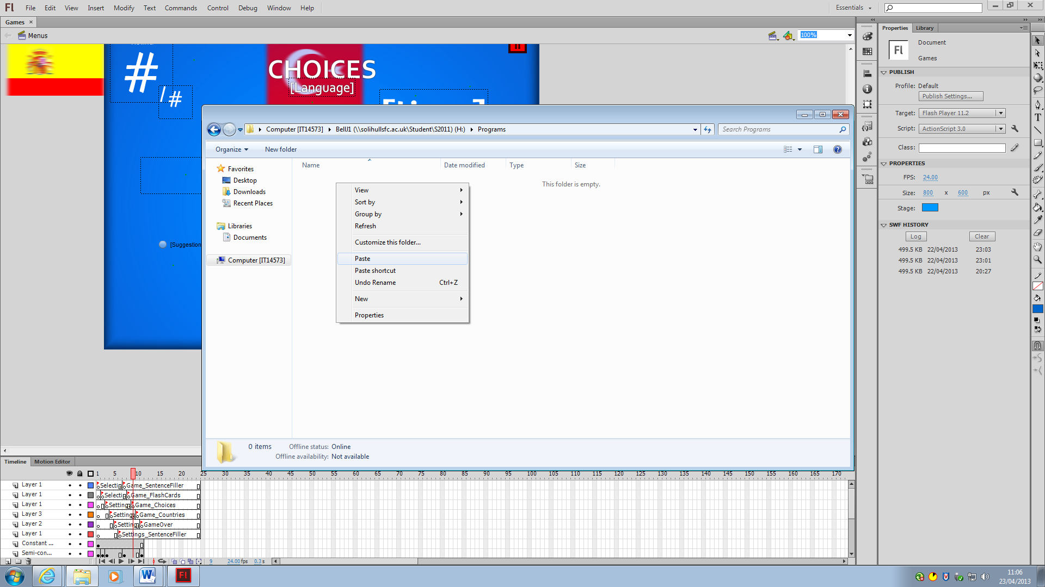

**Paste** the copied file into a folder on your hard drive

**3.**

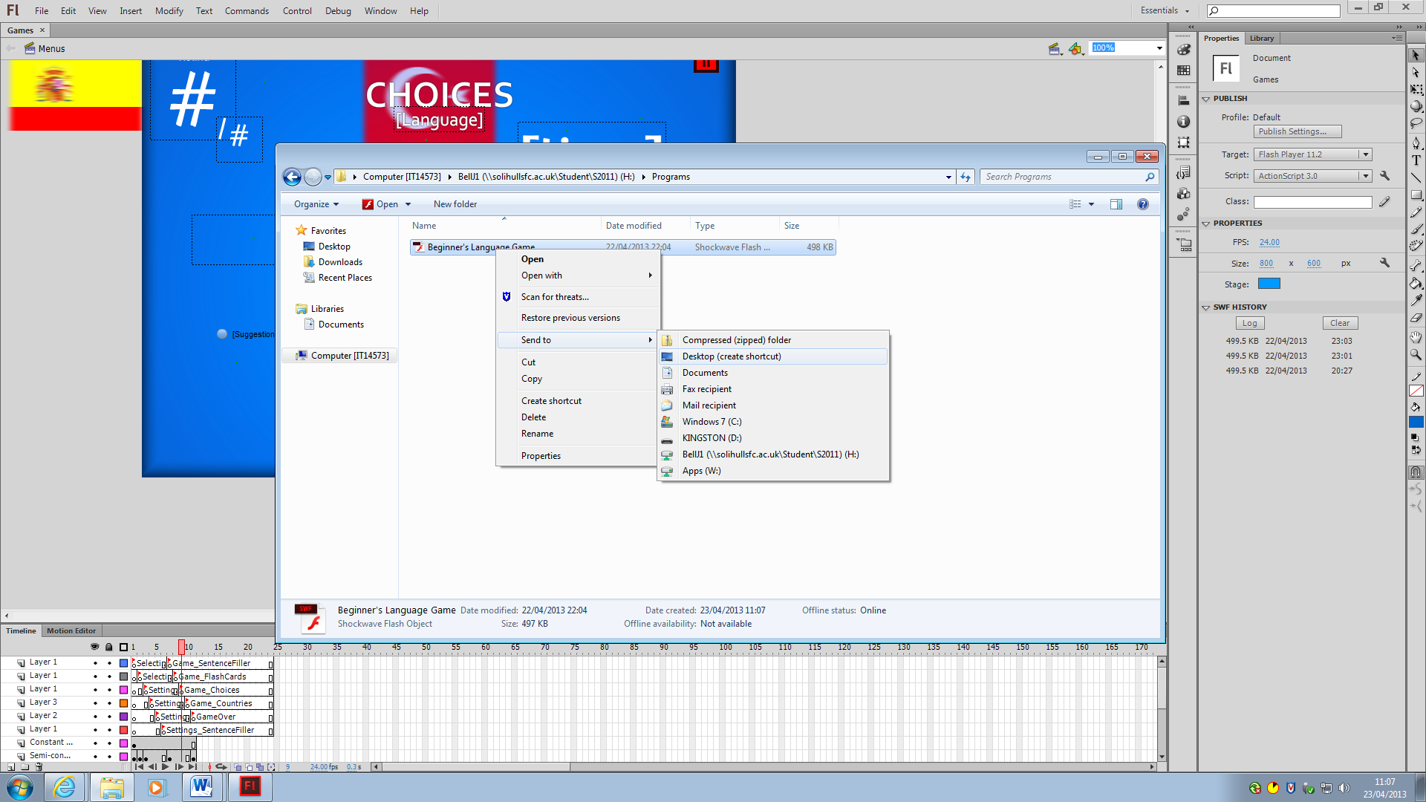

Right-click, go to **Send To** and from the second dropdown menu

select **Desktop (create shortcut)** to add a shortcut to your desktop

Once you have completed these steps, you are ready to begin playing the game. You can do so by either **Opening** the file from its folder, or by clicking the icon which has now been added to your desktop.

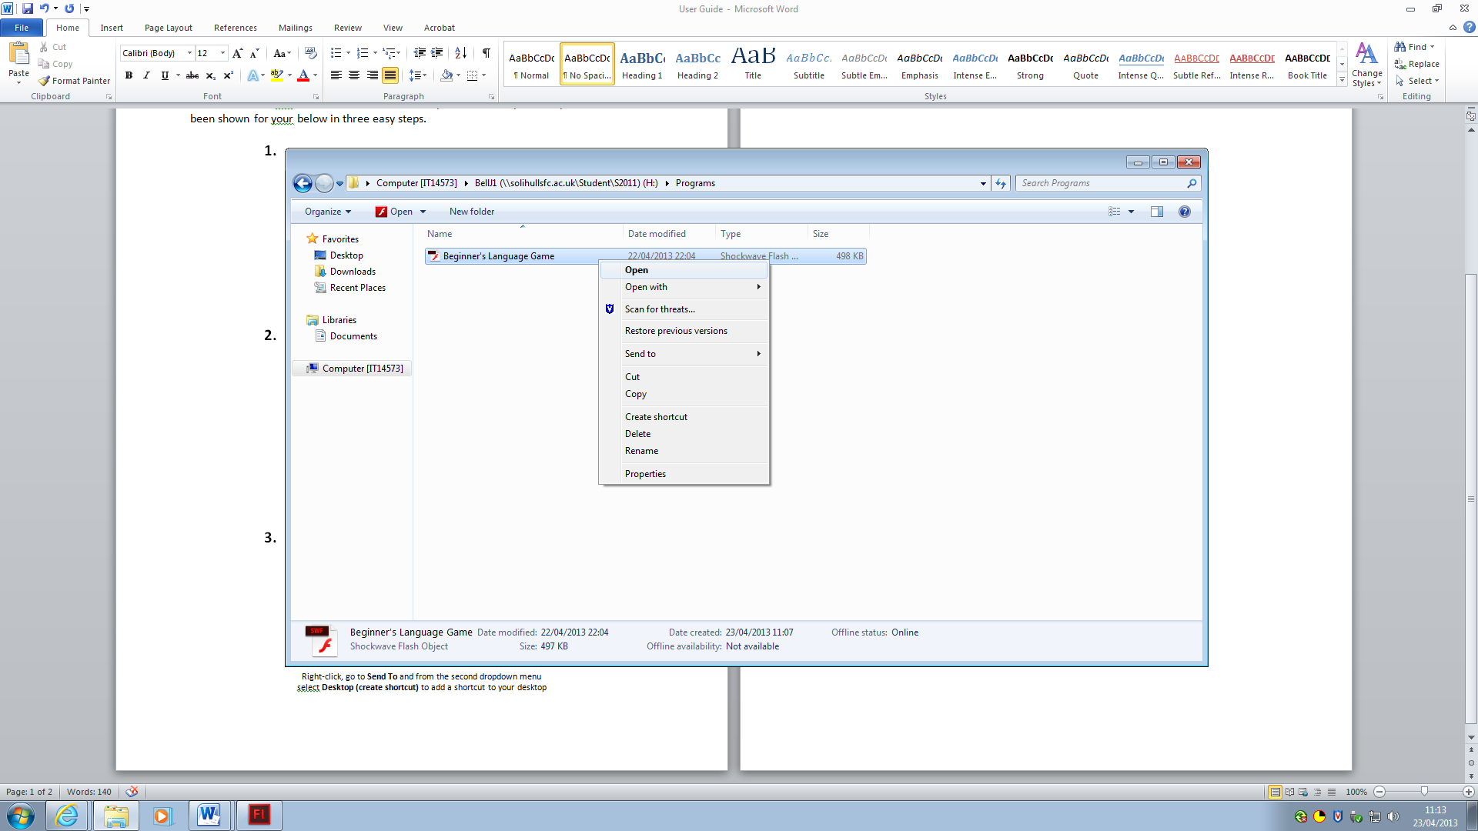

Click **Open** to begin playing

**2** Navigating the Menus

Once you start the game, you’ll be given a few options to select. Before you play your game, you’ll have to choose the language you want to learn. After that, you have a few options of the games to play. Once you have chosen your game, you’ll be given the game settings menu.

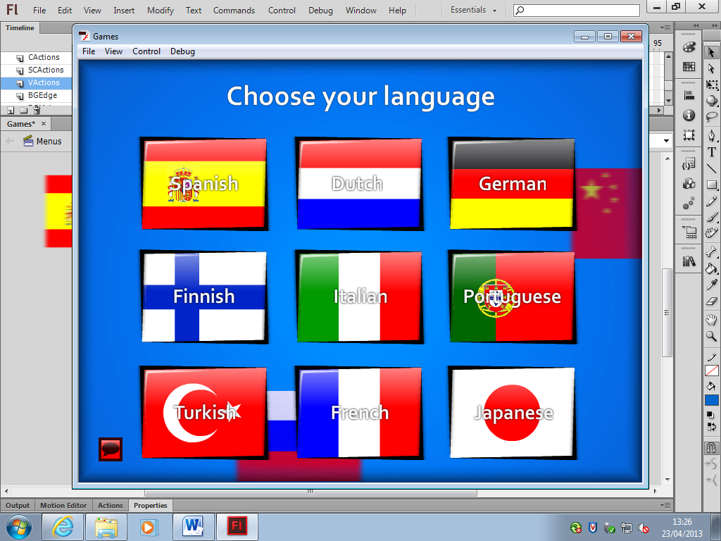

Click on the language you want to learn

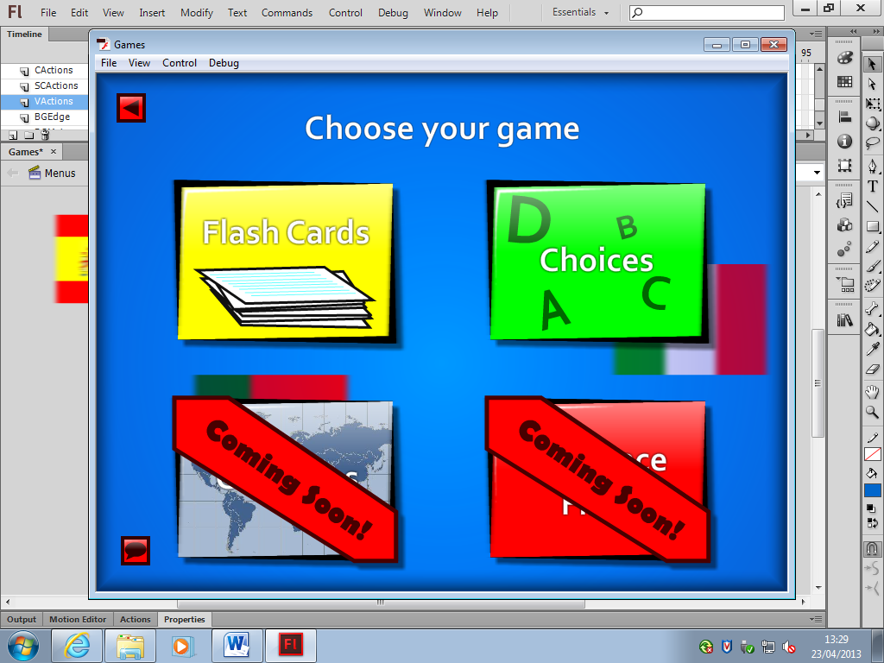

Click on the game you want to play. The bottom two games will be added in a later version

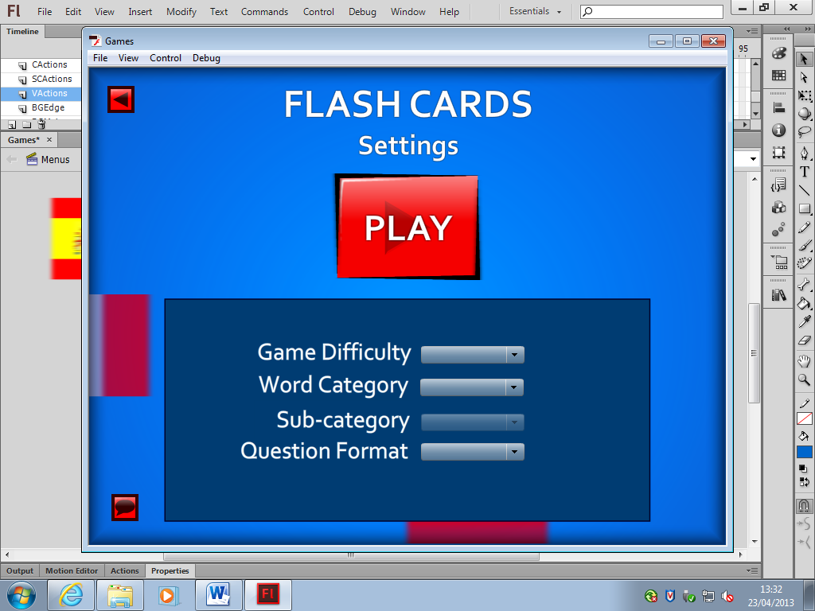

This is the settings screen for the game. See Chapter 3 for more detail.

If you want to go back to a previous menu, you can click the back arrow button in the top right of your screen.



Clicking this arrow will take you to the previous menu

**3** Game settings

Before you can begin playing your chosen game, you need to select your options from the four categories in the settings screen.



2

4

3

1

You can choose your game settings from these combo boxes

1. Game Difficulty

The game difficulty determines the difficulty of the game, but not the difficulty of the words. That is handled by the sub-categories for large lists of words

* Easy
  + Time limit: OFF
  + Incorrect Answers penalty: OFF
* Medium
  + Time limit: ON
  + Incorrect Answers penalty: OFF
* Hard
  + Time limit: ON
  + Incorrect Answers penalty: ON

1. Word Category

Word Category selects the kinds of words you’ll be quizzed on.

* Common Nouns (large)
* Common Verbs (large)
* Common Adjectives (large)
* Numbers (large)
* Travel (large)
* Family (medium)
* Phrases (medium)
* Activities (medium)
* Pronouns (small)
* Colours (small)
* Countries (small)

1. Sub-category

Sub-category displays different options depending on the size of the word category.

For **large** categories, the words are separated into difficulty, giving a more diverse selection of skill testing.

For the **medium** categories, the words are separated into set 1 and set 2 – there is no difference in difficulty between these sets.

Finally, for the **small** categories, there is only one set of words.

* Large
  + Easy
  + Medium
  + Hard
* Medium
  + Set 1
  + Set 2
* Small
  + All Words

1. Question Format

Question format determines the language of the input and output of the game.

* Foreign to English
  + A word of your chosen language is displayed on screen, and you must answer with the word’s English translation.
* English to Foreign
  + An English word is displayed on screen, and you must answer with the translation in your chosen language.

**4** Playing the Games

Once you’ve finished selecting your settings, you are ready to play the game.



Click this button to begin playing!

The User Interface

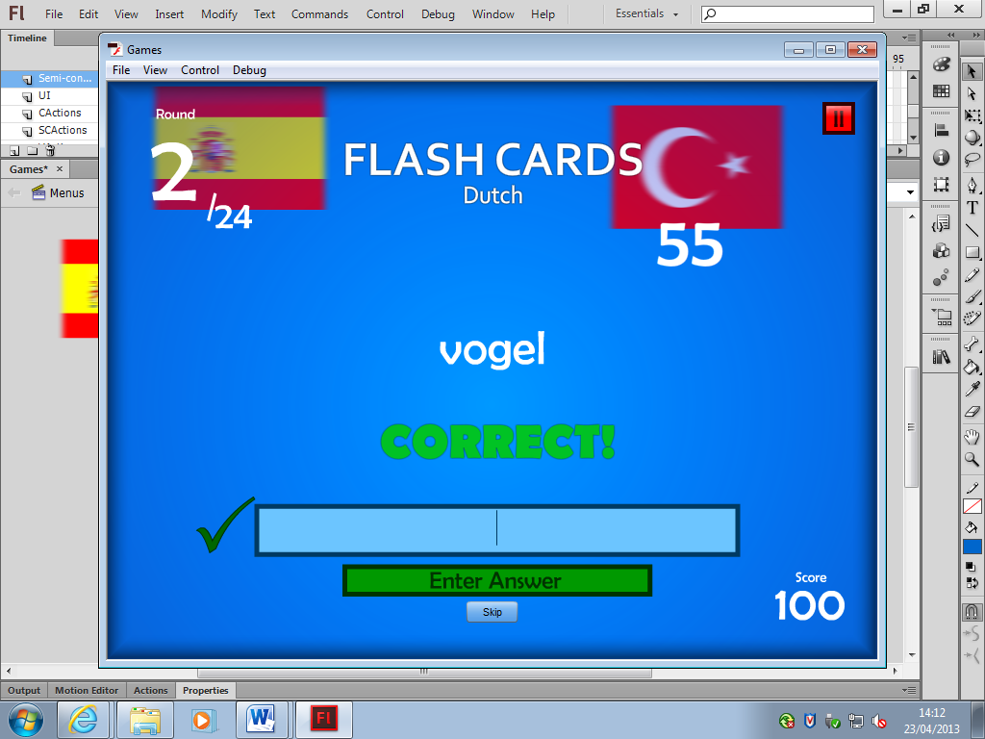

13

12

11

10

91

51

41

2

31

71

81

61

1. Game type you are playing

2. Current round

3. Total number of rounds

4. Current word

5. Correct answer indicator

(**Note**: This will indicate “incorrect” if that is the case)

6. Skip button

7. Enter answer button

(**Note**: Your answer can be submitted either by clicking this button, or by pressing the Enter Key)

8. Current score

9. Input box

(**Note**: This is where you should type your answers)

10. Correct answer verbal response

(Note: This will indicate “incorrect” if that is the case)

11. Current Language

12. Time limit

(**Note**: The game will end if this reaches 0. This will not be present on Easy difficulty)

13. Pause Button will pause the game, and allow you to quit or restart the game.

How to Play

Both Flash Cards and Choices have a similar way to play. In both games, you will be given a word. You must either type in or select the correct translation, for Flash Cards and Choices respectively.

In Hard difficulty, answering incorrectly will penalize your score, so a “Skip” option will allow you to skip a word that you do not know without receiving a penalty.

In Medium and Hard difficulty, there is a time limit. The sooner you complete the game, the higher your time bonus will be at the end. If the timer reaches 0 before you have finished, the game will be ended.

**5** Troubleshooting

Q: I can’t find English in the language selection

A: English is automatically selected as the main language. The language selection screen is where you choose the language that you wish to be tested on, not the language that you speak

Q: